UNIT 2
Matter and Chemical Change
UNIT OVERVIEW
During the chemistry unit, you will look at three major areas that have influenced our understanding of our chemistry.
- Exploring and discovering what matter is. You will look at what makes up matter, how they differ from each other, and how matter can be changed (chemical reactions).

- How can matter be classified into different groups? How can we predict how they will react and what makes different chemical similar?

- How can we control chemical reactions? How can we speed them up or slow them down? How are compounds created?

As you work this unit, you will need to provide evidence of your understanding of concepts that related to chemistry and matter. Use this table to keep track of your progress and where you have shown clear understanding.
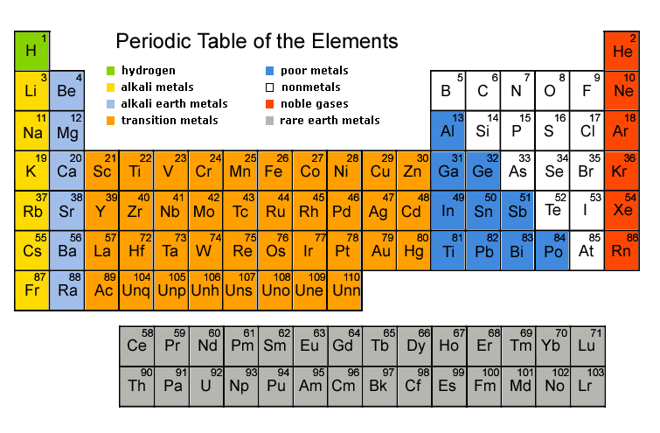

Science 9 Matter and Chemical Change
Knowledge Outcomes
1. Investigate materials, and describe them in terms of their physical and chemical properties. |  | Still Learning | On My Way | With Ease
 | The big ideas/Enduring Understandings (Rocks) | Include evidence.
Can I describe and apply different ways of classifying materials based on:
- their composition?
- their properties?
-including:
- pure substances, solutions and
mechanical mixtures
−metals and nonmetals
−other methods of classification
 | Important to know and be able to do (Sand) | Include evidence.
Can I investigate and describe properties of materials?
(e.g., investigate and describe the melting point, solubility and conductivity of materials observed)
 | Can I identify conditions under which properties of a material are changed?
 | Can I critically evaluate if a new substance has been produced (7 indicators of chemical reactions)?
 | Worth being familiar with (Water) | Include evidence.

Science Matter and Chemical Change
Knowledge Outcomes
2. Describe and interpret patterns in chemical reactions. |  | Still Learning | On My Way | With Ease
 | The big ideas/Enduring Understandings (Rocks) | Include evidence.
Can I observe and describe patterns of chemical change, by:
−observing heat generated (exothermic)
or absorbed (endothermic) in chemical
reactions
−identifying evidence for conservation of
chemical substance
(e.g., identify and apply techniques for comparing the quantity of reactants and products in a chemical reaction)
Can I identifying conditions that affect rates of reactions?
(e.g., investigate and describe how factors such as heat, concentration, surface area and electrical energy can affect a chemical reaction)
Can I identify evidence for conservation of chemical substance (Law of Conservation of Mass)?
(e.g., identify and apply techniques for comparing the quantity of reactants and products in a chemical reaction)
 | Important to know and be able to do (Sand) | Include evidence.
Can I observe and describe evidence of chemical change in reactions between familiar materials, by:
- describing combustion, corrosion and other reactions
- involving oxygen (oxidation)
- observe and give evidence of chemical reactions between familiar household materials

Can I observe and describe evidence of chemical change in reactions between familiar materials, by:
- describing combustion, corrosion and other reactions
- involving oxygen (oxidation)
- observe and give evidence of chemical reactions between familiar household materials

 | Can I identify and evaluate dangers of caustic materials and potentially explosive reactions?
 | Worth being familiar with (Water) | Include evidence.

Science 9 Matter and Chemical Change
Knowledge Outcomes
3. Describe ideas used in interpreting the chemical nature of matter, both in the past and present, and identify example evidence that has contributed to the development of these ideas. |  | Still Learning | On My Way | With Ease
 | The big ideas/Enduring Understandings (Rocks) | Include evidence.
Can I use the periodic table to identify the number of:
- Protons?
- Electrons?
- and other information about each atom?

Can I describe, in general terms, the relationship between the structure of atoms in each group and the properties of elements in that group?
(e.g., use the periodic table to determine that sodium has 11 electrons and protons and, on average, about 12 neutrons; infer that different rows (periods) on the table reflect differences in atomic structure; interpret information on ion charges provided in some periodic tables)
 | Can I distinguish between ionic and molecular compounds, and describe the properties of some common examples of each?
 | Important to know and be able to do (Sand) | Include evidence.
Can I distinguish between observation and theory, and provide examples of how models and theoretical ideas are used in explaining observations?
(e.g., describe how observations of electrical properties of materials led to ideas about electrons and protons; describe how observed differences in the densities of materials are explained, in part, using ideas about the mass of individual atoms)

 | Can I understand the origins of the periodic table, and relate patterns in the physical and chemical properties of elements to their positions in the periodic table (focusing on the first 18 elements)?
 | Worth being familiar with (Water) | Include evidence.

Science Matter and Chemical Change
Knowledge Outcomes
4. Apply simplified chemical nomenclature in describing elements, compounds and chemical reactions. |  | Still Learning | On My Way | With Ease
 | The big ideas/Enduring Understandings (Rocks) | Include evidence.
Can I identify examples of combining the number (ratio) of atoms per molecule found in some common materials, and use information on ion charges to predict the number of atoms (combining ratios) in ionic compounds of two elements?
(e.g., identify the number of atoms per molecule signified by the chemical formulas for CO(g) and CO₂(g); predict combining ratios of iron and oxygen based on information on ion charges of iron and oxygen)
Can I read and interpret chemical formulas for compounds of two elements, and give the IUPAC (International Union of Pure and Applied Chemistry) name and common name of these compounds?
(e.g., give, verbally and in writing, the name for NaCl(s) (sodium chloride), CO2(g) (carbon dioxide), MgO(s) (magnesium oxide), NH3(g) (nitrogen trihydride or ammonia), CH4(g) (carbon tetrahydride or methane), FeCl2(s) (iron(II) chloride), FeCl3(s) (iron(III) chloride)
Describe familiar chemical reactions, and represent these reactions by using word equations and chemical formulas and by constructing models of reactants and products?
(e.g., describe combustion reactions, such as: carbon + oxygen → carbon dioxide [C(s) + O2(g) → CO2(g)]; describe corrosion reactions, such as: iron + oxygen→ iron(II) oxide [Fe(s) + O2(g) → FeO(s)]; describe replacement reactions, such as the following: zinc + copper(II) sulfate→ zinc sulfate + copper [Zn(s) + CuSO4(aq) → ZnSO4(aq) + Cu(s)])

 | Important to know and be able to do (Sand) | Include evidence.
Can I assemble or draw simple models of molecular and ionic compounds?
(e.g., construct models of some carbon compounds using toothpicks, peas and cubes of potato)
 | Worth being familiar with (Water) | Include evidence.
Can I identify/describe chemicals commonly found in the home, and write the chemical symbols?
(e.g., table salt [NaCl(s)], water [H2O(l)], sodium hydroxide [NaOH(aq)] used in household cleaning supplies)

