Science 9 Plants for Biological Diversity
1. Investigate and interpret diversity among species and within species, and describe how diversity contributes to species survival. |  | Still Learning | On My Way | With Ease
 | The big ideas/Enduring Understandings (Rocks) | Include evidence.
Can I observe variation (differences) in living things, and describe examples of variation:
- Differences between one species and another
- Differences between members of the same species
(e.g., observe and describe characteristics that distinguish two closely related species)
Can I identify examples of niches?
- how the role of variation (adaptations) helps closely related living things to survive in the same ecosystem

Can I investigate how organism’s interaction links the survival of one species to the survival of another?
(e.g., by providing habitat, food, means of fertilization, or a source of oxygen)
Can I identify the role of variation in species survival under changing environmental conditions?
(e.g., resistance to disease, ability to survive in severe environments)
 | Important to know and be able to do (Sand) | Include evidence.
 | Worth being familiar with (Water) | Include evidence.
Unit 1 – BIOLOGICAL DIVERSITY
UNIT OVERVIEW
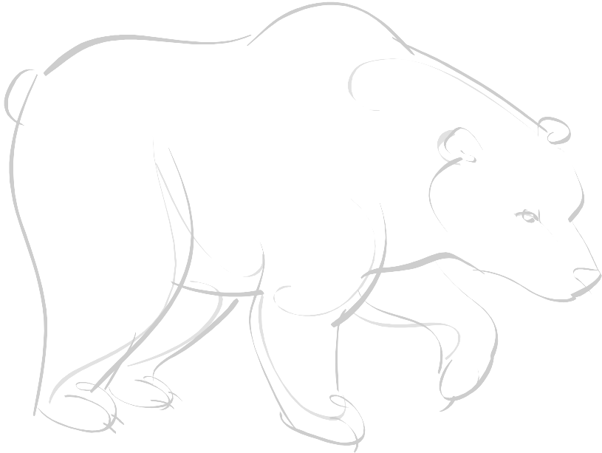
By studying biological diversity, you will understand the process why species differ from each other, why there are subtle variations within species, and the impact of human activity on them. You will also explore human initiatives to minimize loss of diversity, though both local and global strategies.

As you work this unit, you will need to provide evidence of your understanding of concepts that related to biological diversity. Use this table so keep track of your progress and where you have shown clear understanding.
Science 9 Plants for Biological Diversity - Knowledge Outcomes
2. Investigate the nature of reproductive processes and their role in transmitting species characteristics. |  | Still Learning | On My Way | With Ease
 | The big ideas/Enduring Understandings (Rocks) | Include evidence.
 | Can I distinguish between sexual and asexual reproduction?
 | Can I understand and show examples of asexual and sexual reproduction in different species, by:
−describing types of asexual reproduction and organism that use it
(e.g., fission in the amoeba, budding in hydra, production of zoospores in some fungi)
-describing types of sexual reproduction and organism that use it
(e.g., cross-fertilization in seed plants, sexual reproduction in mammals)
−describing examples of organisms that show both sexual and asexual reproduction
(e.g.,yeasts that reproduce both by budding and sexual reproduction; plants that reproduce through suckering, runners or bulbs, as well as by seed production)
 | Can I describing the formation of zygote and embryo in plant and animal reproduction?
 | Can I identify examples of both discrete and continuous variation? (e.g., hand clasping preference is an example of a discrete variation, the length of human hands varies on a continuum)
 | Important to know and be able to do (Sand) | Include evidence.
 | Can I identify characteristics that are heritable from those that are not heritable?
 | Can I identify characteristics for which heredity (nature) and environment (nurture) may both play a role?
 | Can I show the transfer of characteristics from parents to offspring?
Can I identify examples of characteristics in offspring that are:
− the same as the characteristics of both parents
− the same as the characteristics of one parent
− intermediate between parent characteristics
− different from both parents
 | Worth being familiar with (Water) | Include evidence.
 | Can I describe examples of variation within a species?
 | Can I identify examples of both discrete and continuous variation? (e.g., hand clasping preference is an example of a discrete variation, the length of human hands varies on a continuum)

Science 9 Plants for Biological Diversity
3. Describe, in general terms, the role of genetic materials in the continuity and variation of species characteristics; and investigate and interpret related technologies. |  | Still Learning | On My Way | With Ease
 | The big ideas/Enduring Understandings (Rocks) | Include evidence.
 | Can I compare sexual and asexual reproduction, in terms of the advantages and disadvantages?)
Can I distinguish between, and identify examples of:
- natural selection
- artificial selection (selective breeding)
(e.g., evolution of beak shapes in birds, development of high milk production in dairy cows)
Can I describe, in general terms, the relationship of:
  - chromosomes
  - genes
  - DNA
 | Can I interpret their role as carriers of genetic information?
 | Important to know and be able to do (Sand) | Include evidence.
Can I distinguish between cell division that leads to identical daughter cells:
- as in binary fission and mitosis
- cell division that leads to formation of sex cells, as in meiosis

 | Can I describe, in general terms, the synthesis (production) of genetic materials that takes place during fertilization?
 | Worth being familiar with (Water) | Include evidence.
 | Can I describe, in simple terms, some of the newly emerging technologies for recombining genetic material?
 | Can I identify questions and issues related to their application?

Science 9 Plants for Biological Diversity
4. Identify impacts of human action on species survival and variation within species, and analyze related issues for personal and public decision making. |  | Still Learning | On My Way | With Ease
 | The big ideas/Enduring Understandings (Rocks) | Include evidence.
 | Important to know and be able to do (Sand) | Include evidence.
Can I identify the benefits and drawbacks of various local and global strategies for minimizing loss of species diversity?
(e.g., breeding of endangered populations in zoos, development of seed banks, designating protected areas, development of international treaties regulating trade of protected species and animal parts)

 | Can I describe ongoing changes in biological diversity through extinction and extirpation of native species?
 | Can I investigate the role of environmental factors in causing loss of biodiversity?
 | Worth being familiar with (Water) | Include evidence.
 | Can I describe why there are so many species in some areas on Earth and few species in another (Generalists/Specialists)?
 | Can I describe the use of biotechnology in environmental, agricultural or forest management?
 | Can I identify potential impacts and issues of using genetic engineering?

